**Room booking system 23/24**

All student societies and clubs can book any committee room, Barbara Straing Teaching centre rooms or equipment within the union free of charge, provided they are a ratified society or club. You can book all committee rooms yourself providing you have no tech requirements other than the av equipment already available in the committee rooms. If you wish to book the venue or any other room and you require any of the following: microphone, speaker, catering, bar or tables and chairs, then contact either [kenzie.james-hastings2@ncl.ac.uk](mailto:kenzie.james-hastings2@ncl.ac.uk) or [dawn.hathaway2@ncl.ac.uk](mailto:dawn.hathaway2@ncl.ac.uk) who will then handle this booking.

We also have limited access to BSTC.1.46, a large, tiered lecture theatre in the Barbara Straing Teaching Centre. Should you require use of the space please contact Dawn Hathaway on [dawn.hathaway2@ncl.ac.uk](mailto:dawn.hathaway2@ncl.ac.uk).

You can also request space on Campus e.g. Herschel, medical school or Armstrong. This can only be requested using the following link: <https://forms.ncl.ac.uk/view.php?id=2051>

Please note you should only request space elsewhere on campus if you cannot find available space on NUSU room booking system.

Please remember, no food or drink can be consumed in any University space.

If you wish to book the area outside at the front of the union, Please contact [dawn.hathaway2@ncl.ac.uk](mailto:dawn.hathaway2@ncl.ac.uk)

Luther’s bar is not an exclusive bookable space, however you would like to use these facilities for a club or society event, please contact [oc2.union@ncl.ac.uk](mailto:oc2.union@ncl.ac.uk) or ob1.union@ncl.ac.uk.

Should you require the use of outdoor space we have a 3m x 3m stretch tent permanently set up on the forum next to the 24 hour access door which is free to use and bookable via reception. If you require power for these tents you must email [kenzie.james-hastings2@ncl.ac.uk](mailto:kenzie.james-hastings2@ncl.ac.uk) at the time of your booking to organise. Power will not be available unless booked in advance.

Room bookings can only be made a maximum of 4 weeks in advance, however if it is a large event which requires being booked earlier than this period, please contact [kenzie.james-hastings2@ncl.ac.uk](mailto:kenzie.james-hastings2@ncl.ac.uk) who will then discuss this with you further.

**Conditions of room bookings**

* Rooms must be left in the original state that you find them
* All rubbish must be disposed of in the bins provided
* Only ratified societies and clubs can access the room booking system
* Only president, treasurer and secretaries can make a room booking providing they are listed on the societies committee, however only the Presidents will receive the log in details and confirmation emails from the room booking system
* Bookings can only be made 4 weeks in advance
* A maximum of two rooms can be booked per day
* No food or drink other than bottled water can be consumed in university rooms
* Food and drink may only be consumed in NUSU’s room provided they are shop bought and sealed and we have been informed of this prior to the event.

**To make a booking**

Go to <https://nusu.roombookingsystem.co.uk>.

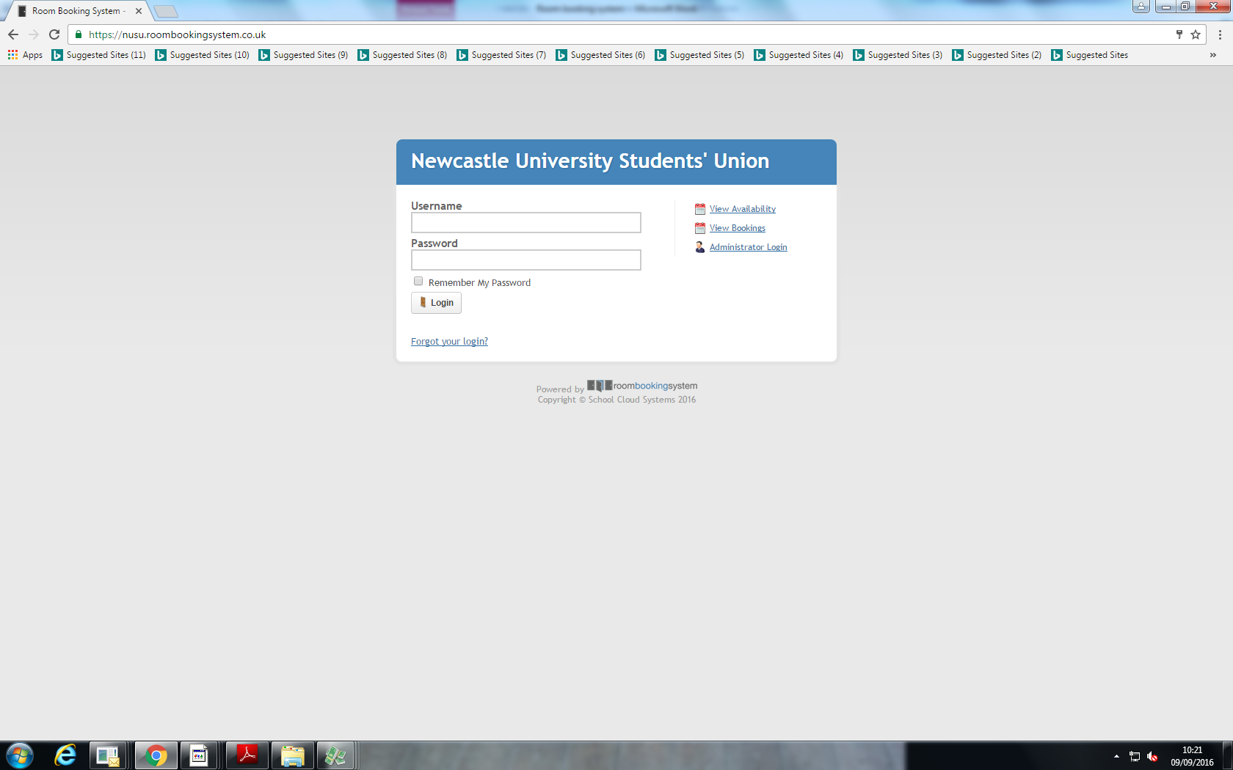

Your username has been emailed to the president with instructions how to create a password. If you need any assistance with an initial log in, please contact sop.union@ncl.ac.uk

1. Once logged in, go to the calendar tab

On the left of the screen you will see a list of resource categories, Barbara Straing Teaching Centre, Committee rooms, loan equipment, the list of rooms available are broken down into sections, which consist of the flowing:

**Committee rooms**-, Bamburgh, Etal, Ford (available all day) these rooms are located in the Hadrian Building opposite Luther’s bar terrace.   
Kate Aidie, Martin Luther King, History room, Daniel Wood – all level 1 in student union building.

**Barbara Straing Teaching Centre**

The following rooms are available to book in the Barbara Straing Teaching Centre: BSTC.1.48, BSTC.B.29, BSTC.B.30, BSTC.B.32, BSTC.G.33, BSTC.G.34 and BSTC.G.36. These rooms are available to clubs and societies 6pm-9pm Monday to Friday during term time only.

1. Choose the user from the drop down list. All societies and clubs have their own log in name (if there is one not listed, please contact [sop.union@ncl.ac.uk](mailto:sop.union@ncl.ac.uk) .
2. Select the time within the room you would like to book and the booking sheet will pop up.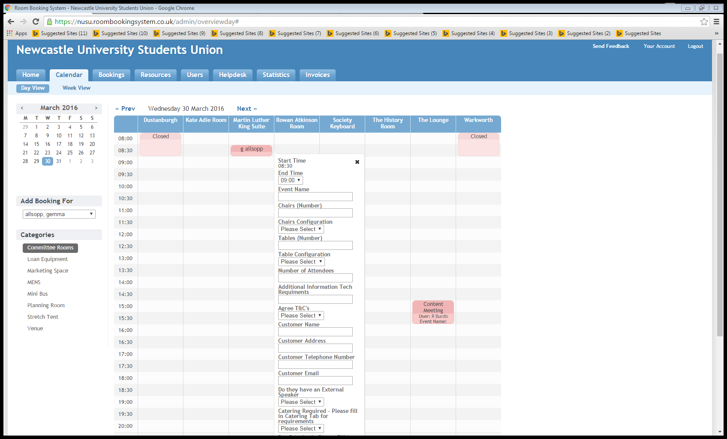
3. Please fill in all required information.
4. Once completed click ‘book’
5. you will then receive a pending email receipt from the room booking system

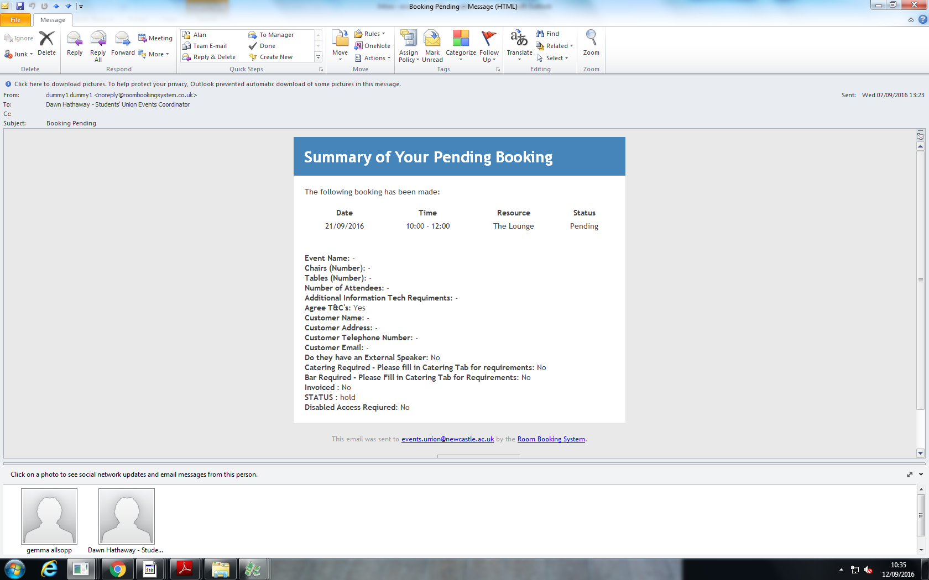

1. Reception will also receive this email and will review your request and either confirm or deny your request. You will receive another email from the room booking system with the outcome of this.

**Venue Bookings**

We can do all types of events including the following:

* Live music
* Fayres
* Exhibitions
* Conferences
* Formal dinners
* Social parties

The space itself to use is free, however the following charges may be incurred.

* Security £20.00 per hour per person (1 per 100 people legal requirement)
* Technician £160 for one technician.
* First aid – quote provided upon request
* Room set up (tables and chairs) £75 (free to use to set up yourself)
* Tea and coffee £1.50 per person

All these charges will charged to your society or club account directly.

* For live events we would generally only require 1 technician however first aid and security may be required.
* For live music events 2 technicians may be required, also if over 500 tickets sold first aid will be required
* For exhibitions, fayres, conferences, formal dinners and social parties only 1 technician will be needed.

We can also cater for all events; Catering menu’s can be provided upon request.

Should you wish to use your own catering companies, we require seeing government issued Food safety certificates and comply with Natasha’s Law allergen information. This should always be discussed with an event coordinator before any orders are placed.

**For any event other than a Club or society meeting held on or off campus requires an event plan to be submitted on SUMS and approved before the Event can take place.**